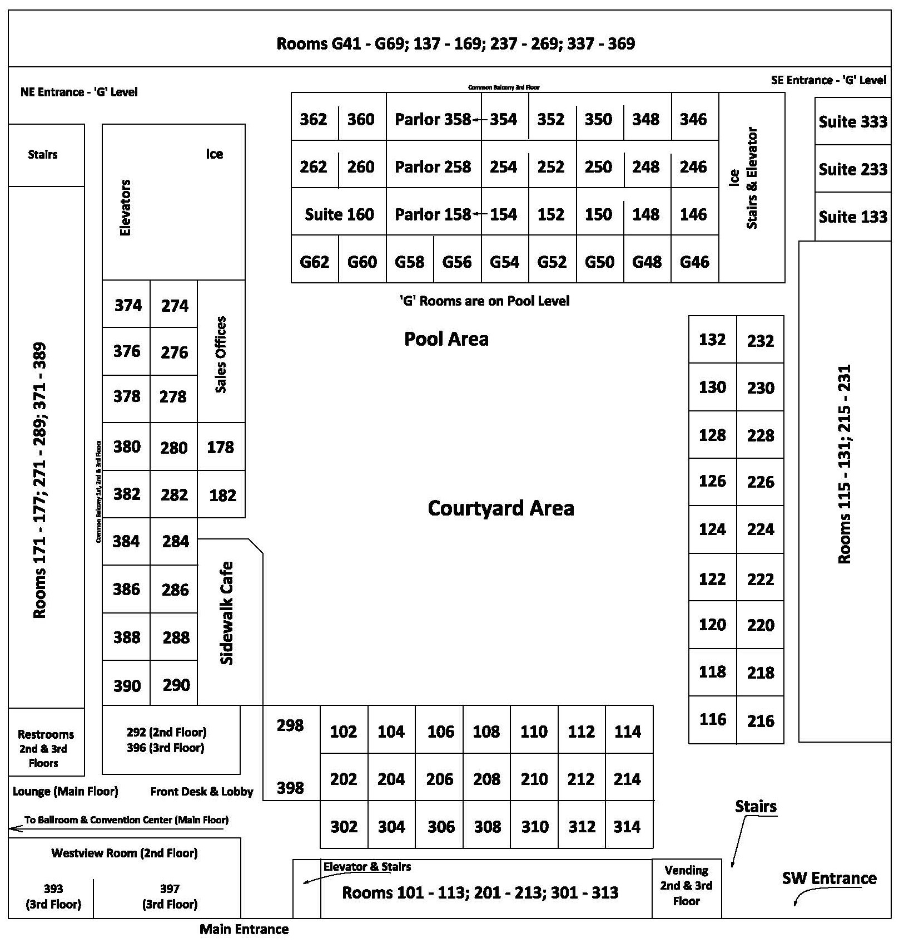
ROOM | VENDOR | ROOM | VENDOR
106 | 4G’s Pyrotechnics | 386 | Lakeside Concessions
110 | Absolute Science | 104 | Liz Gregory Talent  & Productions
132 | Action Theater  Impact Pro Wrestling | 233 | Luehrs’ Ideal Rides
128 | Amusement Associates | 252 | McDermott Family Shows
178 | Artists & Attractions | 384 | Midwest Pullers Association
182 | Bobby Baker Enterprises | 126 | Midwest Sound & Lighting
374 | Bungart Motorsports | 112 | Muessigmann Talent
274 | Carve R Way Chainsaw Carving | 378 | NTPA  National Tractor Pullers Assn.
124 | Circle S Mobile Safari | 260/262 | Next Generation Shows
102 | Critter Close-Ups | 380 | Outlaw Truck & Tractor  Pulling Association
382 | ECIPA  East Central Iowa Pullers Association | 376 | Pro Pulling League
158 | Evans United Shows | 130 | Regalia Manufacturing
284 | Face Designs by Jess | 278 | Rogue Rodeo
282 | Fairs.com  Ticketing, Registration,  Web Design & Digital Marketing | 108 | RW Sound
286 | Get ‘R’ Fried Midway | 290 | Sam’s Amusements
280 | Gotcha Games | 114 | Scott Amusements
160 | Grandstand Concerts | 118 | Smith Entertainment  Concessions
122 | Honey Creek Rodeo | 258 | Staats Awards
133 | Iowa State Fair | 160 | Thunder & Lightning Productions
276 | J & M Displays | 120 | Triangle Talent
288 | Joe’s Old Fashion Fun | 358 | Variety Attractions

2025 Association of Iowa Fairs Conference & Annual Meeting

Associate Member Hospitality Rooms

